# Final Exam

# AI-Lab

# FA21-BCS-136

# ZAID ASGHAR VIRK

**QUESTION NO 1:**

**P1.**

**QUERY:**

Match (p:Person{name:'Tom Hanks'})-[r:DIRECTED]->(m:Movie) return p.name,m.title

**For the released year too:**

Match (p:Person{name:'Tom Hanks'})-[r:DIRECTED]->(m:Movie) return p.name,m.title,m.released

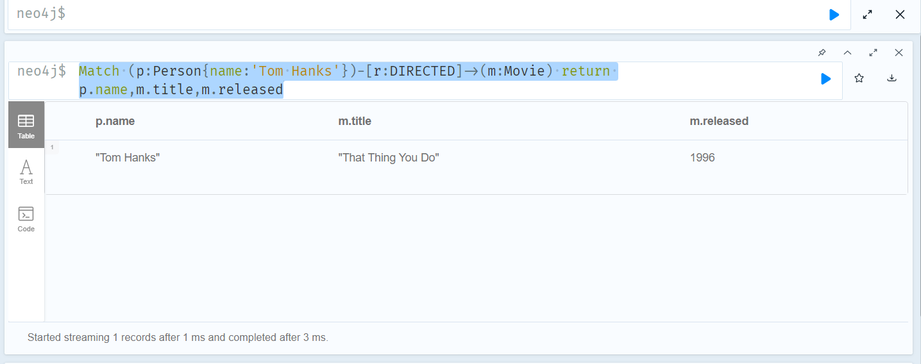

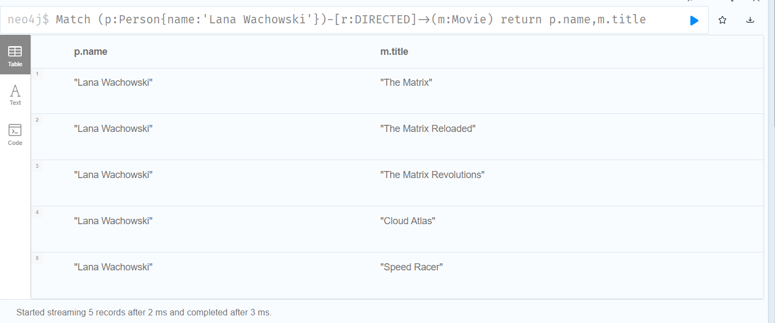

**P2:**

**Query:**

MATCH (p:Person)-[:DIRECTED]->(m:Movie)

WHERE m.released > 2000

RETURN m.title AS MovieTitle, p.name AS Director

**Explanation, Multiple Directors against each movie are being displayed.**

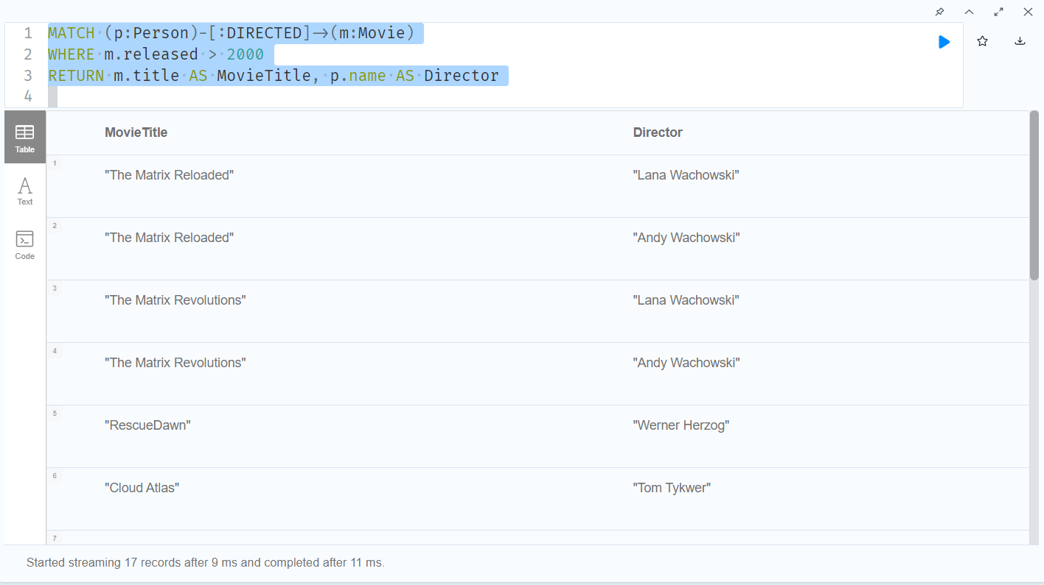

**To Print the name of directors as an array against each movie you can use:**

MATCH (p:Person)-[:DIRECTED]->(m:Movie)

WHERE m.released > 2000

RETURN m.title AS MovieTitle, collect(p.name) AS Director

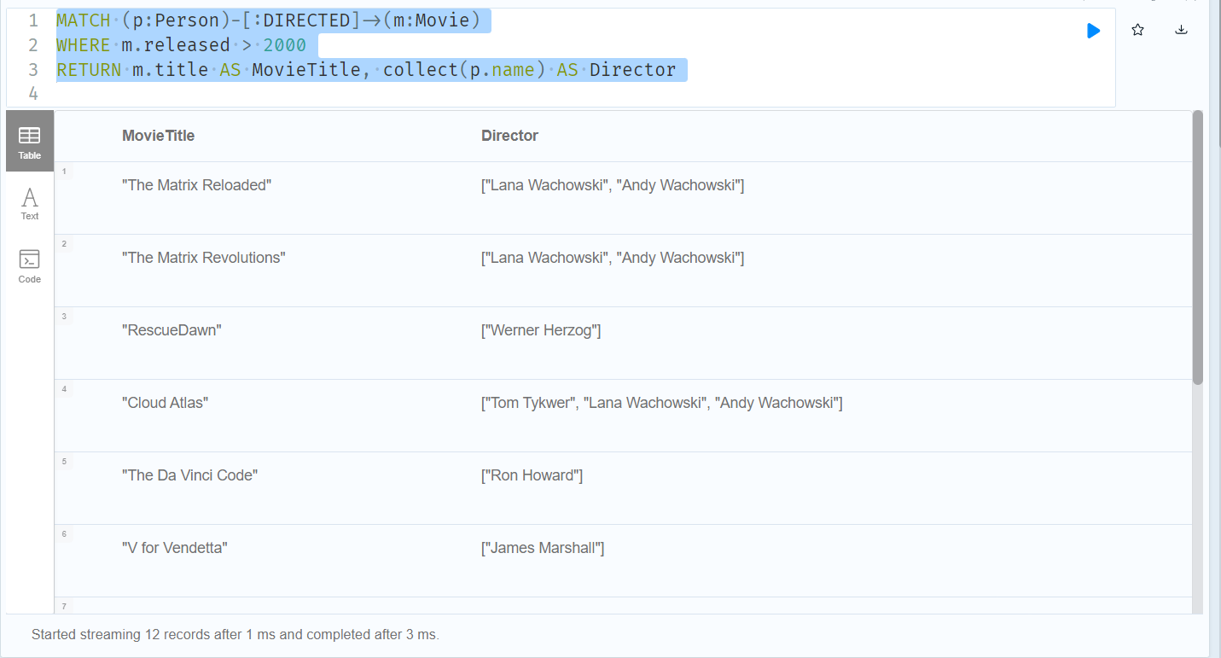

**P3:**

Query:

MATCH (p:Person)-[:ACTED_IN]->(m:Movie)

WITH p, COUNT(m.title) AS l

WHERE l >=3

RETURN p.name,l

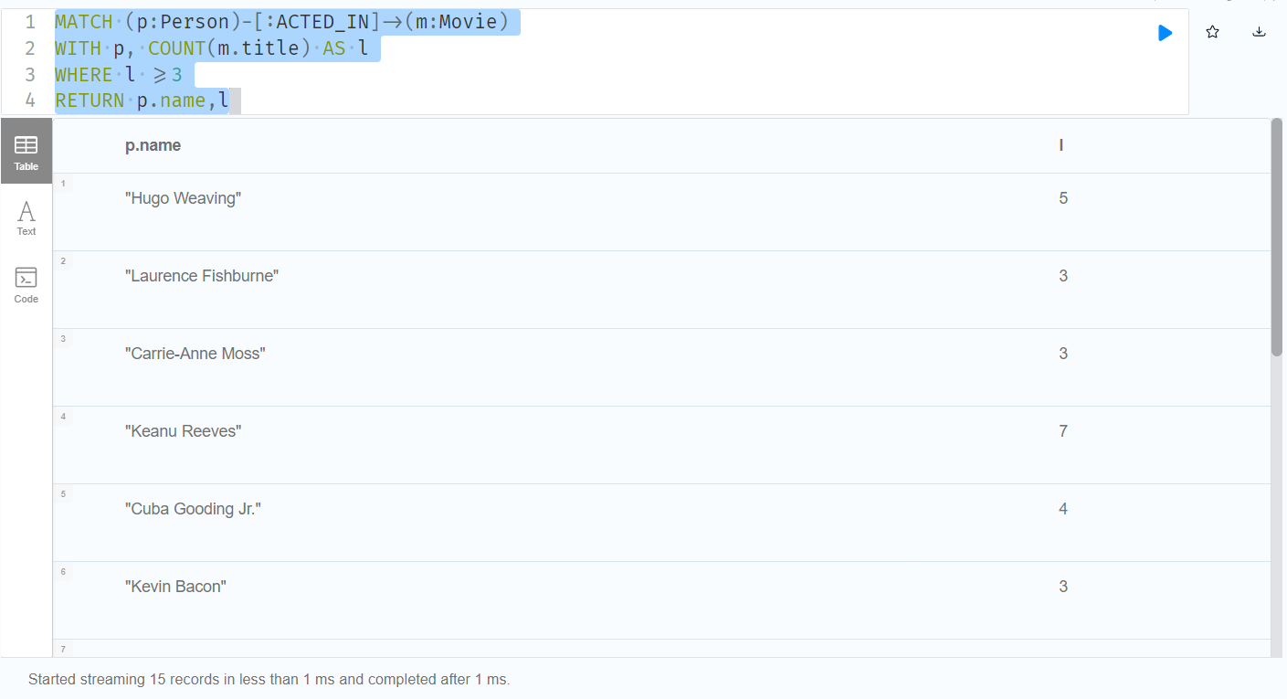

Also for sorting:

MATCH (p:Person)-[R:ACTED_IN]->(m:Movie) with p, count(m) as number where  number>=3 return p.name, number order by  number

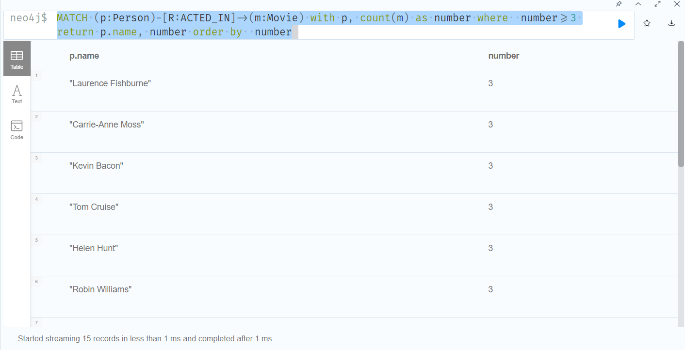

**P4:**

Query:

MATCh (n:Person{name:'Tom Hanks'})-[ACTED_IN]->(m:Movie)<-[PRODUCED]-(p:Person)

MATCH (a:Person)-[:ACTED_IN]->(m)

return m.title as movietitle,  COLLECT(DISTINCT p.name) AS Producers, COLLECT(DISTINCT a.name) AS Actors

